ATV SAFETY TWITTER POSTS
Tweets to Use with Toolkit Graphics:
(Research shows that tweets with images are more likely to attract attention and engagement. We recommend using these tweets with the ATV safety graphics available on the toolkit page and on Flickr.)
June, July, and August are peak months for ATV injuries and deaths. Think twice before allowing kids on ATVs, and if you do, insist on safety. #ATVsafety
ATVs: as fast as a car without the protections of doors, seat belts, and airbags. If you let your child use an ATV, follow these tips to keep them a little safer. #ATVsafety
Go solo: Allow only one person at a time on an ATV. Even if the ATV is designed to carry two people, carrying or riding as a passenger is not safe. #ATVsafety
Choose a youth model ATV designed for your child’s age (adult models are not safe for children younger than 16 years). Enroll your child in a hands-on #ATVsafety course.
Check the sticker: Before you ride, make sure ATV helmets are certified by the Department of Transportation, ANSI, or the Snell Foundation. #ATVsafety
Not actually ALL terrain: ATVs aren’t designed for paved surfaces or roads of any type. Stick to off-road terrain only. #ATVsafety
Children younger than 6 years should NEVER drive ATVs. Period. #ATVsafety
Just because it’s legal to ride an ATV on a public road does not mean it’s safe. Only use ATVs on designated trails or off-road terrain. #ATVsafety

Tweets with Links to Existing Resources
It’s not just the traffic. Staying off paved surfaces and public roads of any type will keep your ATV where it was meant to go: off-road. #ATVsafety http://bit.ly/2yl84Wz
Check out the work these #ATVsafety experts are doing to keep people safe: @ConsumerFed, Injury Prevention Center at @archildrens, and ATV Injury Prevention Task Force at @UIchildrens. http://bit.ly/2leKcKG
@USCPSC has been tracking ATV deaths and injuries for years. Check out its #ATVsafety center for resources, data, and ATV recalls. www.atvsafety.gov
Kate was a bright young girl who loved softball. In between tournament games one day, she went to a friend’s house, hopped onto an ATV, and didn’t come home. Read how Kate’s family is helping other families avoid the same tragedy. #ATVsafety http://bit.ly/2lfM6Ld
Whether you’re new to ATVs or have had them around for years, brush up on #ATVsafety basics from Stead Family Children’s Hospital: http://bit.ly/2lgy5wJ @UIchildrens
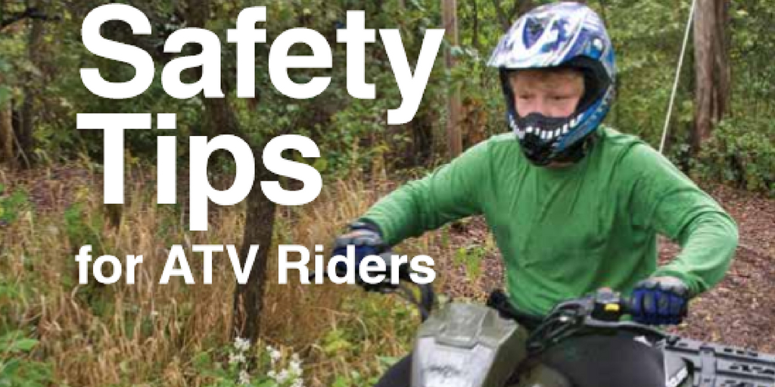

Ask questions before allowing a child to use an ATV. Is the model right for the child’s age? Do you have a certified helmet? Can the child follow rules like staying off-road? If not, say no to ATVs. #ATVsafety http://bit.ly/2lggCog
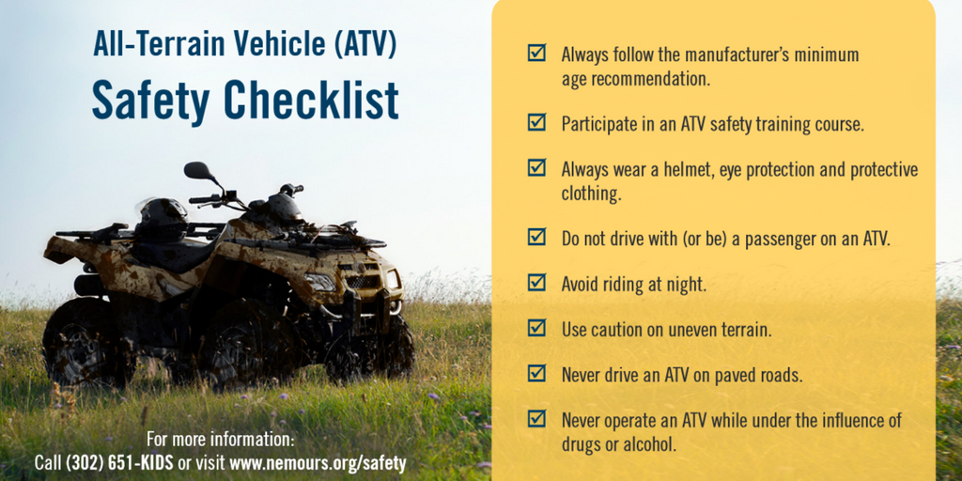

Know your child: if your child has trouble controlling impulses, following rules, or understanding risk, do not let them use ATVs. See the rest of the #ATVsafety infographic from @ChildrensSafety: http://bit.ly/2lfP0Q3
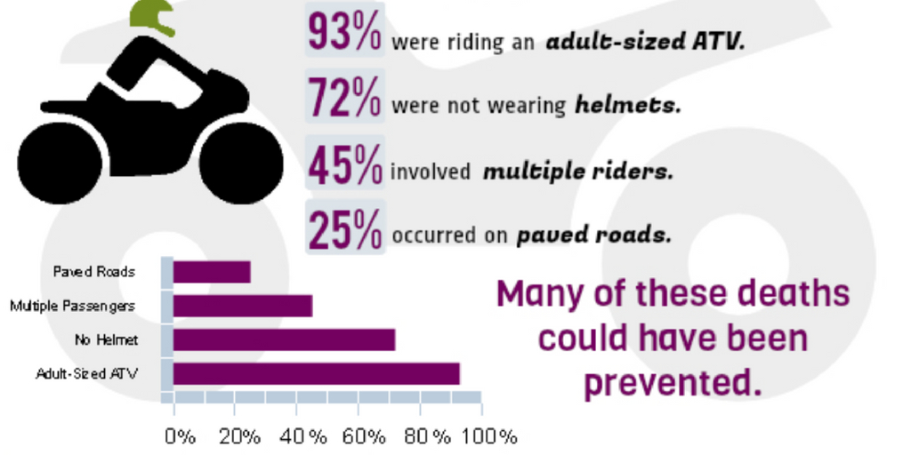

ATVs can weigh hundreds of pounds and roll over easily. Find a training course for your children before allowing them to use ATVs. #ATVsafety
