Teen Driving Twitter Posts
Tweets to Use with Toolkit Graphics:
(Research shows that tweets with images are more likely to attract attention and engagement. We recommend using these tweets with the Teen Driving safety graphics available on the toolkit page and on Flickr. Text on this page highlighted in yellow indicates a resource available on the toolkit webpage.)
It’s National Teen Driver Safety Week. Stay tuned this week for tips and advice on keeping your teen driver safer behind the wheel. #NTDSW
When you get behind the wheel, your teen is watching. Set a good example whenever you drive by following safety laws and wearing your seatbelt. #NTDSW
Drive the way you would want your teen to drive. #NTDSW
Medications can cause slowed reaction time or trouble concentrating. Ask your teen’s doctor if any of the medicine they are taking might affect driving. #NTDSW
Learning how to drive doesn’t end when a teenager gets their license. Have your teen sign a parent-teen driving contract that sets rules about driving. #NTDSW
Inexperience leads to mistakes. Behind the wheel of a car, those mistakes happen fast. Help prevent your teen from making driving errors by practicing how to drive with them at night and in heavy traffic. #NTDSW
Practice driving with your teen in difficult situations, such as driving in heavy traffic, during different weather patterns, and at night. #NTDSW
The first 12 months and 1,000 miles are among the riskiest driving periods in a teen’s life. Before your teen starts driving, keep them a little safer by following this tip. #NTDSW (use a tip graphic)
Your teen may be legally old enough to drive, but are they ready? Look for signs of responsibility and if your teen is not ready, keep practicing until you’re comfortable allowing independent driving. #NTDSW
Teaching a teen to drive can be stressful. When teaching your teen to drive, stay calm and patient, offer positive feedback, and praise good choices. #NTDSW

Tweets with Links to Existing Resources
The risk of car crashes for teens is highest when they first get their license. Parent-teen driving contracts are a great way to set rules about driving after your teen has their license. Use this teen-driving contract from @CDCgov: http://bit.ly/2RAwpxi #NTDSW
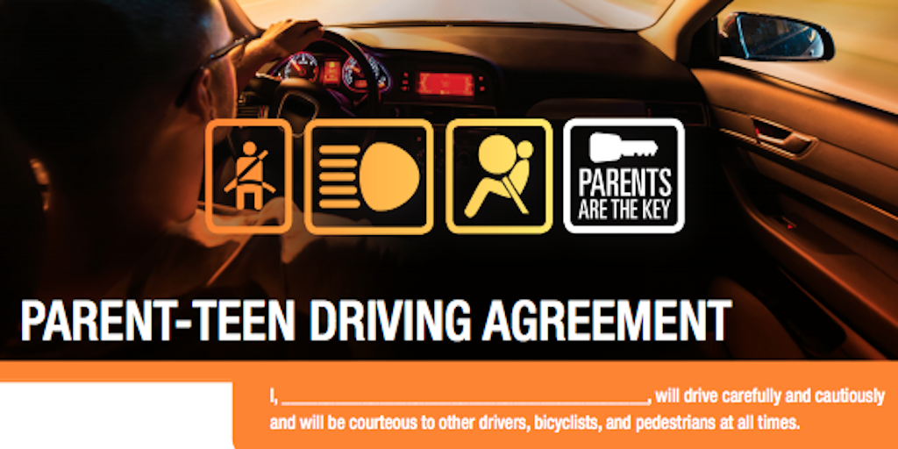
Car crashes are a leading cause of death for teens in the United States. Help your teen drive a little safer by following these tips from @CDCgov: http://bit.ly/2RyVPv2 #NTDSW
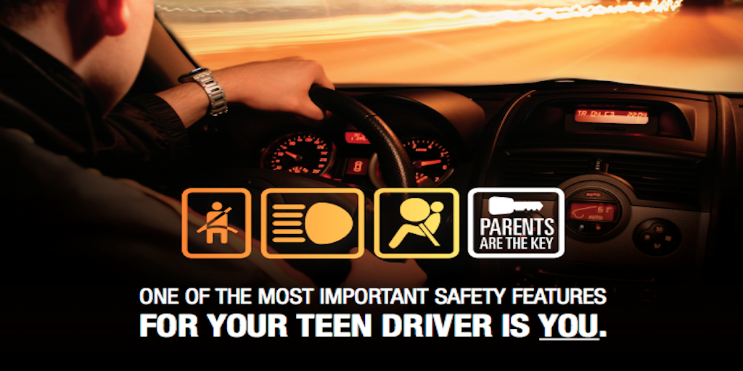
According to experts at the @ChildrensPhila, parents of teen drivers rarely talk about important skills such as scanning the road and detecting hazards. This guide will help you cover ALL the necessary skills for safe driving. http://bit.ly/2E8ktQx #NTDSW
Teaching your teen to drive can be stressful and frustrating, but remember they are still learning. Learn how to communicate with your teen about safe driving with this video from @ChildrensPhila: http://bit.ly/2RAzayw #NTDSW 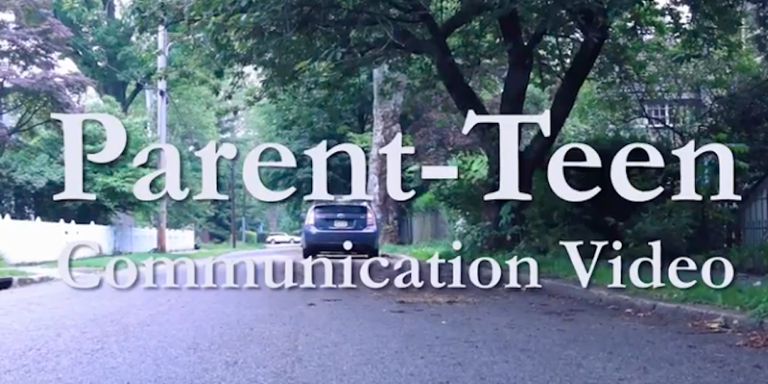
Graduated driver licensing laws exist in every state to help ease teens into the responsibility of driving. Before your teenager takes the keys, make sure you both know the law in your state with this resource from @GHSAHQ. http://bit.ly/2OHWU5e #NTDSW

