Sledding Safety Twitter Posts
Tweets to Use with Toolkit Graphics:
(Research shows that tweets with images are more likely to attract attention and engagement. We recommend using these tweets with the sledding safety graphics available on the toolkit page and on Flickr. Text on this page highlighted in yellow indicates a resource available on the toolkit webpage.)

Every year thousands of children are sent to the hospital with serious injuries from sledding. Before your child hits the hill, consider these safety tips. #sledding (use tip graphic)
The best sleds can be steered and are not snow tubes or round disks. Always check a sled for broken or missing parts since these could hurt a child. #sledding
Children younger than 12 years must always be supervised on the sledding hill. Pick an area for your child to sled that is free from objects and has plenty of room for the sled to come to a stop. #sledding
Always have your child sled during the daytime when there is plenty of light to see any objects that could get in the way. #sledding
Serious injuries can happen when sleds are pulled by moving vehicles like cars and snowmobiles. Keep sleds on the hills and let gravity, not motors, do the work. #sledding
Tweets with Links to Existing Resources:
Sleds can go as fast as 25 miles per hour. Always have your child wear a helmet, such as a snow sports helmet or bicycle helmet, when sledding. Follow these safety tips from @NationwideKids to keep your child safe while sledding. #sledding http://bit.ly/2QUHEzy
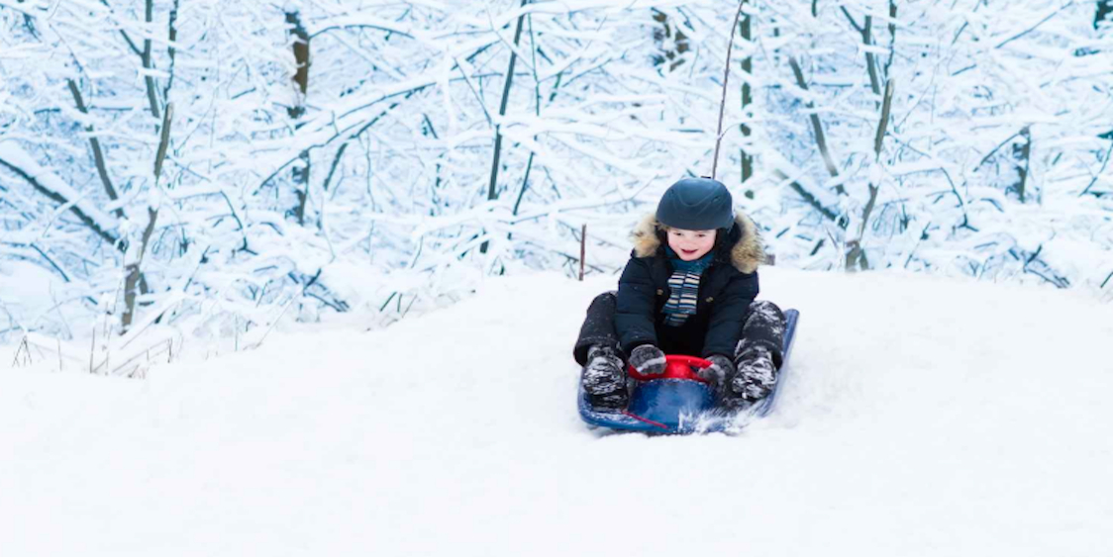
Bruises, cuts, and broken bones are the most common sledding injuries. Follow these safety tips from @CIPAInjury to make sure your child stays on the sledding hill and out of the hospital. #sledding http://bit.ly/2qLK8oK
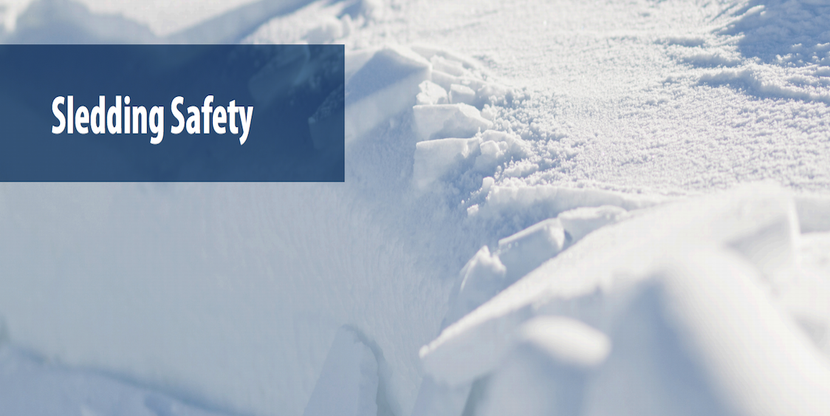
Davyin collided with another student on a sledding field trip and got a broken skull and concussion. Hear Davyin’s story and learn why children need to wear helmets while sledding. #sledding http://bit.ly/2TizuTt
