TEEN PEDESTRIAN SAFETY: CROSSING THE STREET FACEBOOK POSTS

Posts with Links:
The National Highway Transportation Safety Administration reported a nearly 10% rise in pedestrian injuries and deaths in 2015. Teens and older children are more at risk than younger children, so talk to your teens today about why it’s important to be a good pedestrian. http://bit.ly/2uOAUJ2
A report from Safe Kids Worldwide suggests that teens and older children regularly cross the street in an unsafe way, which exposes them to serious injury or death. Help keep the teens in your life safer by talking to them about pedestrian safety. http://bit.ly/2tKTYIe
The risk of injury goes up when a pedestrian crosses the street. Many teens and older children listen to music, talk on the phone, or text while they cross, so they may not see or hear the dangers around them. http://bit.ly/2tbBXRr
Parents might assume that their older children know how to use sidewalks and roadways safely, but research is showing a spike in pedestrian injuries in the past few years. Help keep them safer on foot by reviewing pedestrian safety steps. http://bit.ly/2uOAUJ2
Posts with Graphics:
(Note: Examples only. Use full-resolution images available on the toolkit page and on Flickr.)
Of all the topics parents commonly cover with teens, pedestrian safety probably isn’t at the top of the list. Research shows, however, that maybe it should be: teens ages 12-19 years are one of the higher risk groups for pedestrian injury and death.
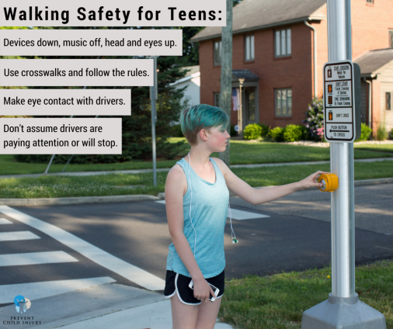

Children and teens across the country are heading back to school. You might think that your older children and teens have mastered how to cross the street safely, but studies show that they might not be as safe as you think. Even if your kids are well past elementary school, it’s worth reminding them of these simple rules for being a safe pedestrian.
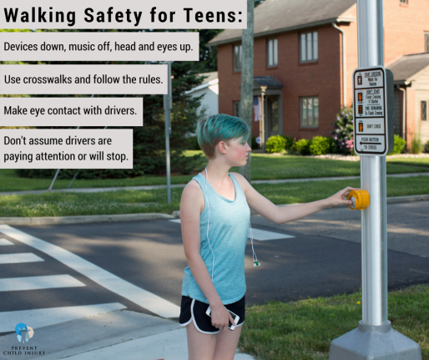
Pedestrian safety: wasn’t that covered in kindergarten? The belief that some safety skills are mastered in elementary school could be why teenagers say they hear less about safety from their parents than when they were younger. Take a few minutes to remind your teens about the rules for walking safely.
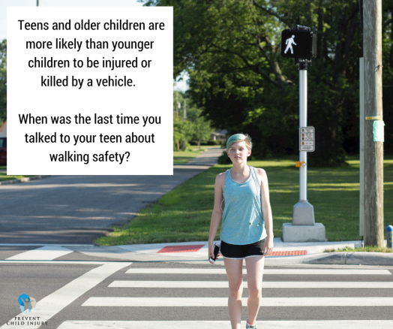
Teens and older children might not realize that they’re at higher risk for pedestrian-related injuries and death than younger children, but research shows about 5 pedestrians ages 12-19 years are killed every week in the U.S. and hundreds more are injured. Talk to your children about safely walking not only to and from school but every time they head out on foot.
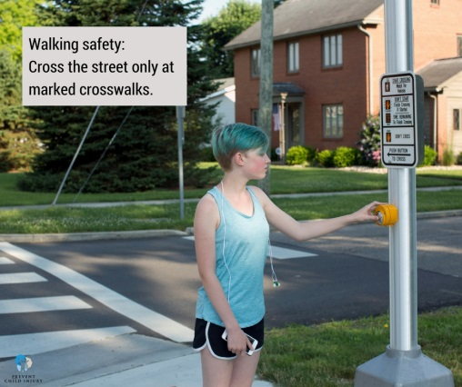
If your children walk or bike to school, finding a safe route is a top priority. With pedestrian injuries and deaths on the rise, it’s worth a few minutes to remind your family of the rules of the road, including crossing only at marked crosswalks, following signals, paying attention, and avoiding distraction by turning off music and putting down devices.
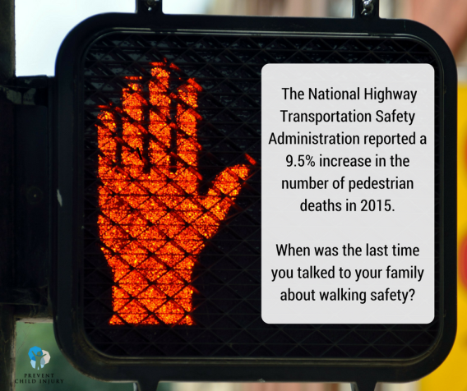

Teen pedestrians are more likely than younger children to be injured or killed by a vehicle, but many teens do not realize that they ARE at risk. Even if your children don’t walk to school, make a point to talk to your teens and older children about being safe pedestrians.
